Emma Green
Using the Binary Search Algorithm and trace table examples at the end of this document, complete the trace tables below for the Color Array. Upload this document to github and submit the link to your repository to the dropbox.

1st search: violet
First | Last | Middle | Comparison
0 | 10 | 5 | Violet > Indigo
6 | 10 | 8 | Violet > Red
9 | 10 | 9 | Violet = Violet
 |  |  | Return True

2nd search: green
First | Last | Middle | Comparison
0 | 10 | 5 | Green < Indigo
0 | 4 | 2 | Green > Chartreuse
3 | 4 | 4 | Green = Green
 |  |  | Return True

3rd search: yellow
First | Last | Middle | Comparison
0 | 10 | 5 | Yellow > Indigo
6 | 10 | 8 | Yellow > Red
9 | 10 | 9 | Yellow > Violet
10 | 10 | 10 | Yellow = Yellow
 |  |  | Return True

Color array:
aqua | [0]
brown | [1]
chartreuse | [2]
dark brown | [3]
green | [4]
indigo | [5]
lavender | [6]
magenta | [7]
red | [8]
violet | [9]
yellow | [10]

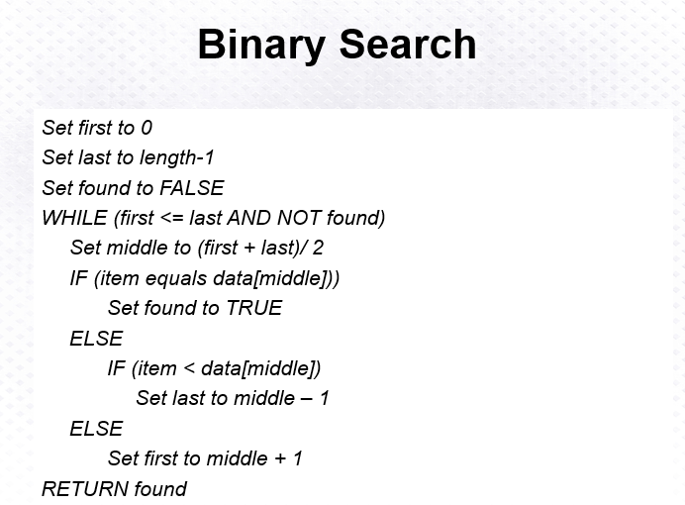
Above: Binary Search Algorithm
